MINUTES OF MEETING SOUTH KENDALL
COMMUNITY DEVELOPMENT DISTRICT

The regular meeting of the Board of Supervisors of the South Kendall Community Development District was held on May 28, 2021 at 9:00 a.m. at Tuscany Village Clubhouse, 12801 SW 133rd Terrace, Miami, Florida.

Present and constituting a quorum were:

Jesus Hernandez Sergio Valdes Betty Fayad Ernesto Frye

Also present were:

Luis Hernandez Ginger Wald Yamilex Ortega Lisette Blanco Jose Escalante

FIRST ORDER OF BUSINESS
Chairman
Vice Chairman Assistant Secretary Assistant Secretary

District Manager District Counsel Club Manager Resident Resident

Roll Call

Mr. Luis Hernandez called the meeting to order and called the roll.

SECOND ORDER OF BUSINESS Organizational Matters
- Consideration of Appointment of Supervisor to Unexpired Term of Office for Seat #3
- Oath of Office for Newly Appointed Supervisor
- Election of Officers
These items were tabled until the next meeting.

THIRD ORDER OF BUSINESS Approval of Minutes of the
March 26, 2021 Meeting
Mr. Luis Hernandez: Item #3 is Approval of Minutes of the March 26, 2021 Meeting. This would be the time to make any changes, corrections, additions, or deletions. If there are none, then a motion to approve the minutes would be in order at this time.

On MOTION by Mr. Valdes seconded by Mr. Jesus Hernandez with all in favor the Minutes of the March 26, 2021 Meeting were approved as-presented.

FOURTH ORDER OF BUSINESS Acceptance of Audit for Fiscal
Year Ending September 30, 2020
Mr. Luis Hernandez: Moving forward, the next item for the Board to consider is the audit for fiscal year ending September 30, 2020. Since we have audience members, what is important for you to know is that the audit is done by an independent auditor. It is a clean audit and just needs to be accepted into the District's records. So, unless there are any questions or comments regarding the audit, I will be looking for a motion to accept it for the District's records.
On MOTION by Mr. Jesus Hernandez seconded by Ms. Fayad with all in favor the audit for fiscal year ending September 30, 2020 was accepted.

FIFTH ORDER OF BUSINESS Discussion of Rules and
Regulations as per the CDC, Miami-Dade County, and the State of Florida
Mr. Luis Hernandez: Moving forward, next we have Discussion of Rules and Regulations as per the CDC, Miami-Dade County, and the State of Florida. As of yet, there is a gray area of what the state is saying as to reopening things. Based on that, the intent for this meeting is to define within the existing rules what needs to be discussed. For the homeowners to know, this is a COD, the South Kendall COD, and this is the Board. It is important for everyone to know that based on the CDC ruling, it has been indicated that anyone in the District who is vaccinated should be able to use the facilities. The problem is that you cannot ask someone if they have been vaccinated or not and someone could be lying and say they have been even if that is not true. So, with that being said, the Board can discuss some of these concerns now.
Mr. Valdes: So, with that being said, along with the property management attendees, we have drafted something and I think it probably makes sense to start reopening some things and at this point, what we are proposing is that starting June 1st,

we increase capacity of the pool and gym to 75%, opening the clubhouse from 8:00 a.m. to 8:00 p.m. as opposed to 9:00 a.m. to 7:00 p.m. as we had been doing currently. We would also open all of the machines in the gym. Social distancing would still be maintained obviously since we are concerned for everyone's safety . Hopefully everyone is vaccinated , but since we cannot ask, we don't really know that. The number of visitors, since we are going to be at 75% capacity, under normal circumstances in the past were four visitors per home, so the question now for the Board would be about that.
Mr. Luis Hernandez: And by visitors, you mean guests.
Mr. Valdes: Yes. Summer is coming. We are still at 75% capacity. Maybe what we can do, and this is just an idea, so maybe the rest of you can share, maybe we can have two guests per home in June, and then in July if we go to 100% capacity, then we can have four guests. I am only suggesting this because there is 75% and we want to make sure that all of the owners have more flexibility if they want to use the pool rather than not be allowed to if one resident shows up with four guests. Some people do have extra people, like say a previous marriage and they may have their kids for the summer who don't reside here year-round. That constitutes as guests because they normally don't live here. If you put on your application that there are four people in the house, and now you are showing up with six people, those extra two would be considered to be guests. Hopefully if things continue to go well and there are no setbacks or changes, obviously with COVID still being around and even if people are vaccinated, I still know people who have been very, very sick from COVID and everything we have been doing here has been to protect the guests and residents who are using the facilities are as safe as possible, as well as the employees who work here. In July, if everything continues as it is, and guidelines we can consider increasing.
Mr. Luis Hernandez: We are hoping for the best, but we will have to follow the guidelines if they are still in place. Just for the members of the Board and audience to understand, we are hoping to move forward, but it will be based on that.
Mr. Valdes: One thing that will stay the same is requiring masks for now. We will see if that can be changed. The other thing is we won't be doing rentals for a while because there is no way to accommodate fifty or sixty people here and if residents want to come use the facilities , it would be impossible with that many people here. There is no

way we can get people to practice social distancing, much less enforce wearing masks. It will be very difficult.
Ms. Wald: Keep in mind you have two conflicting views. You have the Governor who has basically said everything is open, then you have Miami-Dade County, which has certain emergency ordinances in place and that is proceeding to adopt some permanent ones, which obviously would affect this clubhouse. At this current point and time, you can always have the authority over the occupancy for whatever reason , which would mainly be safety and welfare. As to requirements with regards to the masks, it is recommended that the masks should be worn at all times inside. It is recommended.
Mr. Valdes: So, those are the rules and with that being said, we might want to review some of them and we can do this for one month and see how things go and maybe increase levels in July if it is safe to. The amounts of visitors in our area provides more of a chance for this thing to get around and it is better to be safe than sorry. The kids park, I would open that for discussion with the Board. The kids park has been closed for so long and still needs some repairs and we will need someone to take care of those. After that is done I don't know if we want to reopen it, but if we do we need to put those signs up to recommend social distancing so that if you are in there with your kids and someone else comes in with theirs they aren't too close that you don't feel comfortable, and it doesn't turn into a free for all. There are times I have seen one or two kids and that is it, but there are times I have seen multiple children playing. I think that we need to be careful of that. If we do reopen it, we will need to recommend social distancing.
Mr. Luis Hernandez: Any other comments from the other Board members or audience? Not hearing any, I think that we now have a better understanding of what we are trying to accomplish.
Ms. Wald: Since it was brought to our attention, us being the retained professionals for the Board and the Board, there is a conflict in the rules that were adopted a long, long time ago. In these rules, there is a conflict as to sixteen years of age , minors under the age of eighteen and the use of the fitness facility. In one part of the rules, it allows minors to use the gym facility with a waiver signature without the supervision of the parents. Another part of the rules say, specifically for the exercise room, that people under the age of sixteen years of age are not permitted in the exercise room under any

circumstances. So, we have a conflict. When we have a conflict of the existing rules, we know we have to resolve them. Because they are rules of the District that were adopted by resolution, and being a governmental entity, we have to follow this process of advertising the rule change and have a public hearing, kind of similar to what we are doing today so the public can participate in changing the rules and adopting the new ones, and when that happens , the Board hears it, they decide they want these rules in place or not, then we adopt a resolution that puts the rules into effect. Because we have a specific conflict, we cannot enforce either, so what would make sense is to do something reasonable right now that works for the community, and then let's go ahead and fix the problem and we can go ahead and do a formal rule change within the next few months since it takes a while to advertise and have a correction of rules. Normally when we do a rule change, because it is expensive to do the advertisements since two different ones have to be done, and obviously we would like to really look at the rules to see what other things may need to be changed, added, etc. to all of the facilities and not just the exercise room, in this instance I believe, and Sergio please correct me if I am wrong, that it makes sense to allow children who are sixteen years or older to utilize the gym as long they have a waiver from the parent and the parent is here supervising them. The concern is that summer is coming up and you may have a horde of ten sixteen-year-olds using the gym and then you, the taxpayers that live in the community versus the sixteen-year-olds are not going to all be able to use the gym. If you have a parent there, it is probably going to limit that from occurring and they will also make sure they are doing what they are supposed to be doing and properly using the exercise equipment. I think that does make sense and I think that is what you want to present to the Board, right? We will go through the rules process eventually, but in the meantime, we are going to keep doing all along. It has just recently been brought to my attention and I think we do need to fix this. So, I think it does make sense rather than not allowing kids in here at all, especially with summer coming up to allow it under those circumstances so you don't have kids in here constantly as a free-for-all. I think it does make sense to review the rules and in the meantime, keep doing what you have been doing and what we will do is proceed with moving forward with the rule-making process. Now the question I have is this, with proceeding forward with changing the rules, is that what the Board would like to see, the

one that you have been doing all along? Does that make the most sense to the Board, or do we want to do something else?
Mr. Valdes: It makes sense to me. Mr. Jesus Hernandez: Absolutely . Mr. Frye: Yes.
Ms. Wald: So, we will add that and my other suggestion would be for the Board to look at the rules and regulations that we have and see if there are any others that you believe need to be changed, added, amended, subtracted, etc. and we will go ahead and have a meeting, discuss them, then have a formal rule-making process.
Mr. Luis Hernandez: I will send everyone a copy of the rules later today so you can review them and provide any comments. With that, is there anything further that needs to be discussed related to the rules?
Mr. Valdes: No. Ginger, later today can we go over the rules further? Ms. Wald: Yes . We can do that.
Mr. Valdes: Okay, great.

SIXTH ORDER OF BUSINESS Update on the Cleaning of the
Drainage System and Ratification of Invoice 1352-2
Mr. Luis Hernandez: Moving forward, next we have Update on the Cleaning of the Drainage System and Ratification of Invoice 1352-2. Everything has been taken care of but there was an extra charge because one of the baffles needed to be replaced . With that being said, I have presented an invoice to the Board that needs to be ratified because of the additional services they provided. The invoice is from MTX, which is the entity that provided these services in the amount of $12,372.00.
On MOTION by Mr. Valdes seconded by Ms. Fayad with all in favor Invoice 1352-2 from MTX was ratified for an amount of
$12,372.00.

SEVENTH ORDER OF BUSINESS Staff Reports
- Attorney
Mr. Luis Hernandez: Moving forward to Staff Reports. Ginger, anything to report?

Ms. Wald: Nothing. See you all next month when we adopt the budget. Mr. Luis Hernandez : Excellent report.

- Engineer
There not being any report, the next item followed.

- Club
Mr. Luis Hernandez: Anything to report from the club, Yamilex? Ms. Ortega: No.

- Manager - Potential Increase to the Guards to be included in the Proposed Budget
Mr. Luis Hernandez: Moving forward under Manager, the guard's fees has increased from what was in the proposed budget. It is likely that we might need an amendment to the budget because of it.
Ms. Wald: Is it going to change the assessments or cause an increase? Mr. Luis Hernandez : No.
Ms. Wald: Then you are okay.
Mr. Luis Hernandez : I also have another invoice to present that needs to be ratified from Ortiz Construction Services. There were some sidewalks that needed repairs so those were taken care of. The invoice is in the amount of $5,300.
On MOTION by Mr. Valdes seconded by Mr. Jesus Hernandez with all in favor the invoice from Ortiz Construction Services was
ratified for an amount of $5,300.___

EIGHTH ORDER OF BUSINESS Financial Reports
- Approval of Check Run Summary
- Balance Sheet and Income Statement
Mr. Luis Hernandez: Moving forward, Section VIII has the Financial Reports . Tab A contains the check run summary and tab B has the balance sheet and income statement. Unless anyone has any questions on the financials, I will be asking for a motion to approve them at this time.

On MOTION by Ms. Fayad seconded by Mr. Valdes with all in favor the check run summary and the balance sheet and income state_rnent were approved.

NINTH ORDER OF BUSINESS Supervisors Requests
Audience Comments
and

Mr. Luis Hernandez: Are there any Supervisors requests? Hearing none, are there any audience comments?
Ms. Blanco: I don't know if there is anything you can do about the speeding? Mr. Luis Hernandez: The COD doesn't have any authority to control the speed.
Ms. Wald: Every community has the same problems no matter what the speed limit is. I work with other communities not far from here and the speed limits are higher and they have speed bumps everywhere yet people are still speeding. I don't know how they even get over 25 mph with all of the speed bumps everywhere. The only thing that provides any type of resolution and you don't really want to do it because I think it is a waste of money in hiring off-duty police officers to give out tickets. The COD doesn't have police powers to give out tickets so it is really just telling your neighbors to stop speeding, there are children playing everywhere.
Ms. Blanco: I understand. It is just frustrating. Mr. Luis Hernandez: Any other comments?
Ms. Blanco: No. thank you.

TENTH ORDER OF BUSINESS Adjournment
Mr. Luis Hernandez: Unless anyone has anything else to discuss, a motion to adjourn the meeting would be in order.
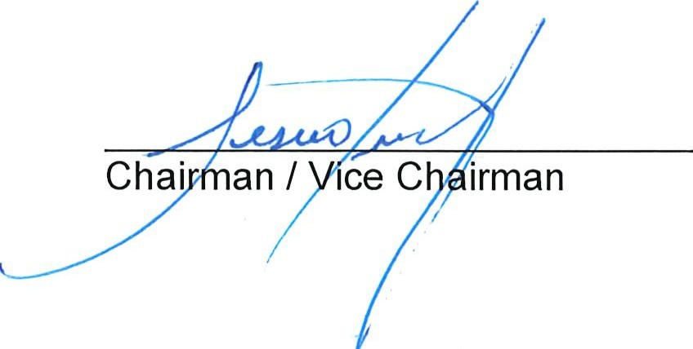

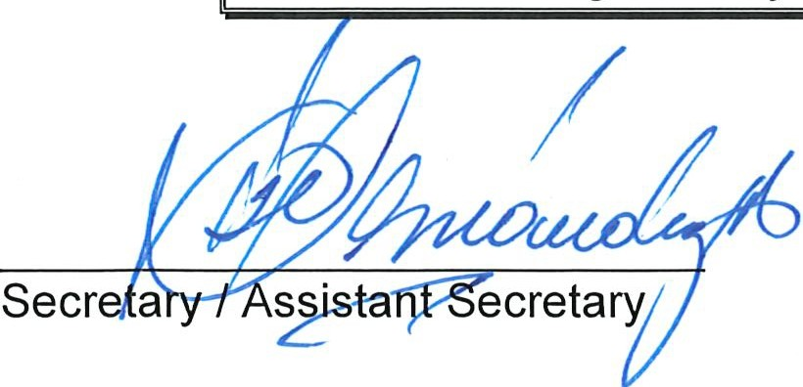
On MOTION by Mr. Valdes seconded by Ms. Fayad with all in favor the meeting was adjourned.

